**RFC-LFP006 (Ooze)**

**Suggested problem**  
Possible ooze in Brygge and in Upper Tang/Tare or bad data?  
  
  
**Suggested solution**

Make use of the four tests below with NO 6506/5-1 S.

**Example**

The raw density log LFP_RHOB_LOG is very low in Brygge and in Upper Tang/Tare. Even though DRHO is larger than usual, the calipher seems fine.

Since ooze has been seen in these formations, it is natural to to try to falsify the hypothesis  
H0: “The zone 1648 m MD – 1785 m MD does not contain ooze”.

Test 1: Temperature range

With the temperature model below (from FWR), we have 49 degC – 54 degC in this zone.

This fits well with the location of transition between Opal-A and Opal-C:

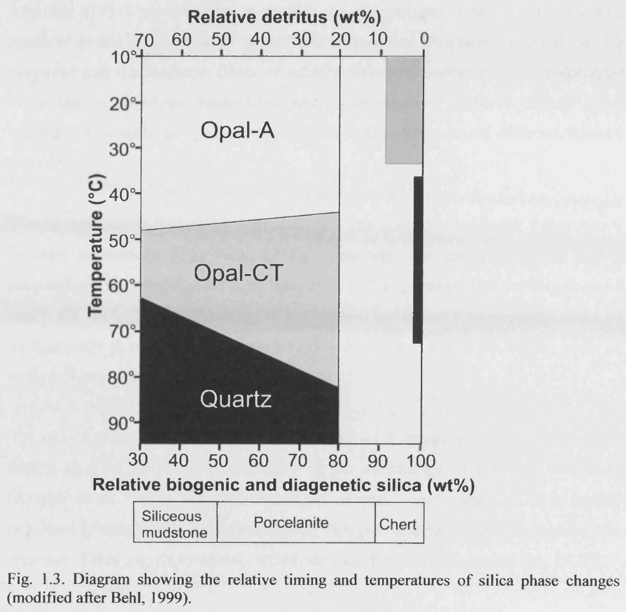

Test 2: Characteristic log behaviour

As described in

Awaldalkarim et al., “Petrophysical Analysis of Siliceous-Ooze sediments, Møre Basin, Norwegian Sea”, Petrophysics 55 (4), pp 333 – 349

, in Opal-A typically bulk density is extremely low, GR is low and DT is high. All these characterisica seems to be fulfilled.

Test 3: Seismic reflection

There should be a reflector at the transition from Opal-A to Opal-CT. Request has been sent to geophysicist. This is his reply:  
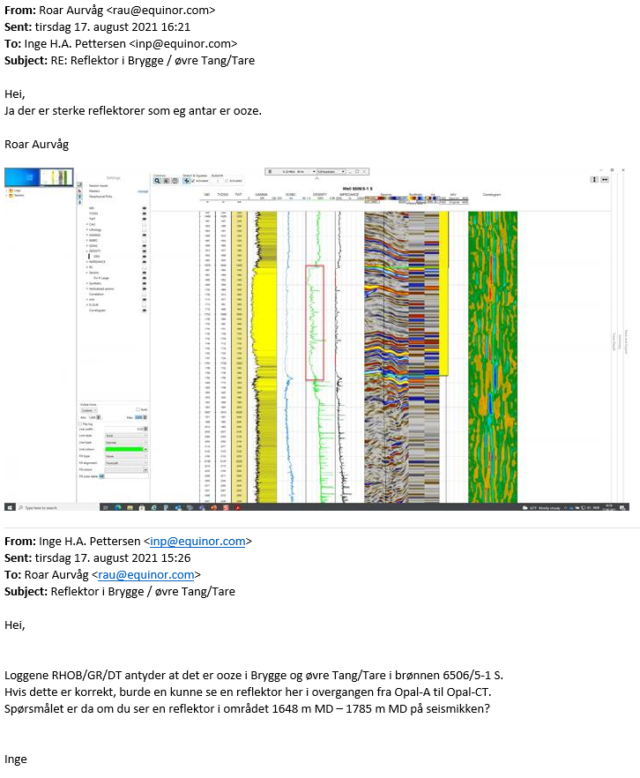

Test 4: Porosity in ooze

From the reference given in Test 2, porosities in the range 0.5 – 0.6 are common in ooze.

The results from Petroeval (assuming RHOMANC = 2.16 g/cm3 from reference in Test 2) are consistent with this.

**Since all tests – Test 1 to Test 4 – falsify hypothesis H0, it is highly probable that the section above contains ooze.**